This assignment constitutes of Market Basket Analysis using Apache Spark FPGrowth Algorithm on Instacart’s Online Grocery Shopping Dataset.

To gauge the probability of a customers inclination to make a preferable purchase; focused on antecedent and consequent values along with confidence.

The following can be found here:

Ingesting data through ETL processes, exploring data using Spark SQL,

Exploring data using Spark SQL,

Executing the FP-Growth Algorithm to execute frequent pattern mining algorithm,

Reviewed association rules generated by the machine learning model.

**Assignment 1:**



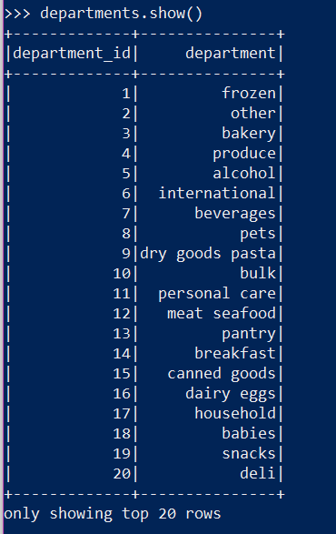

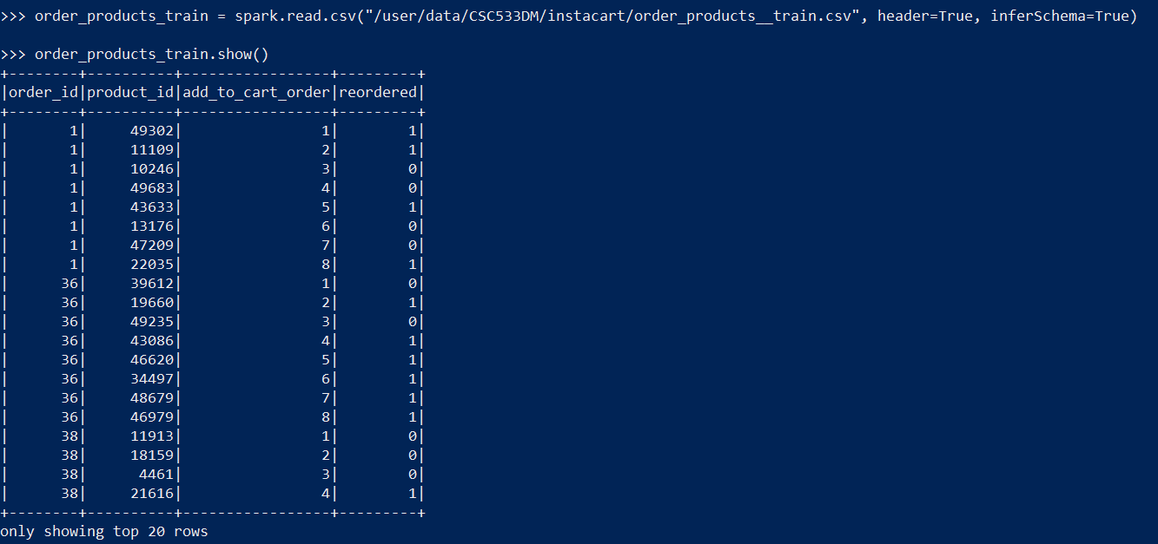

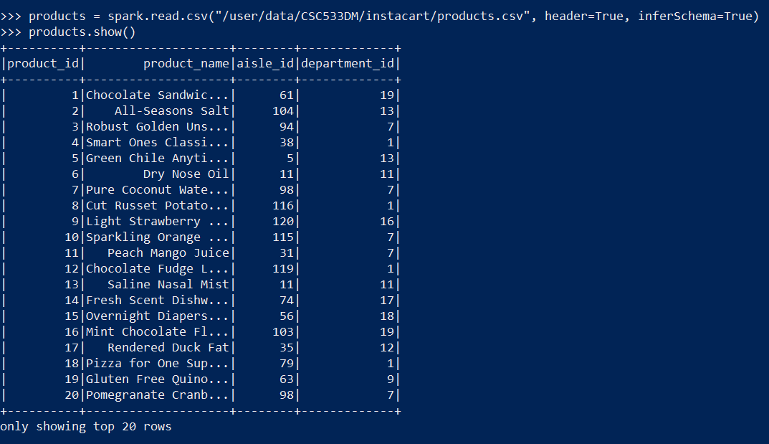

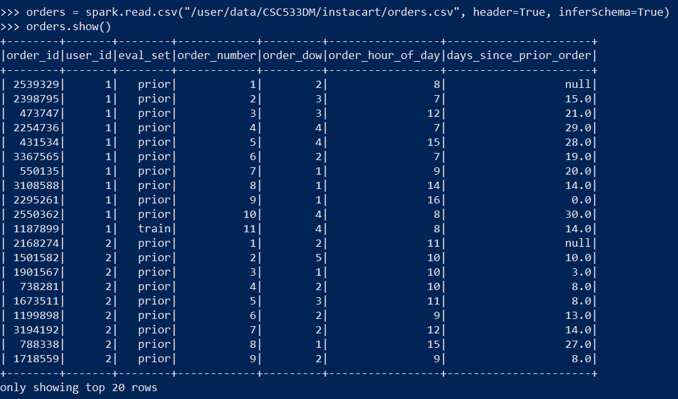

**Assignment 2:**

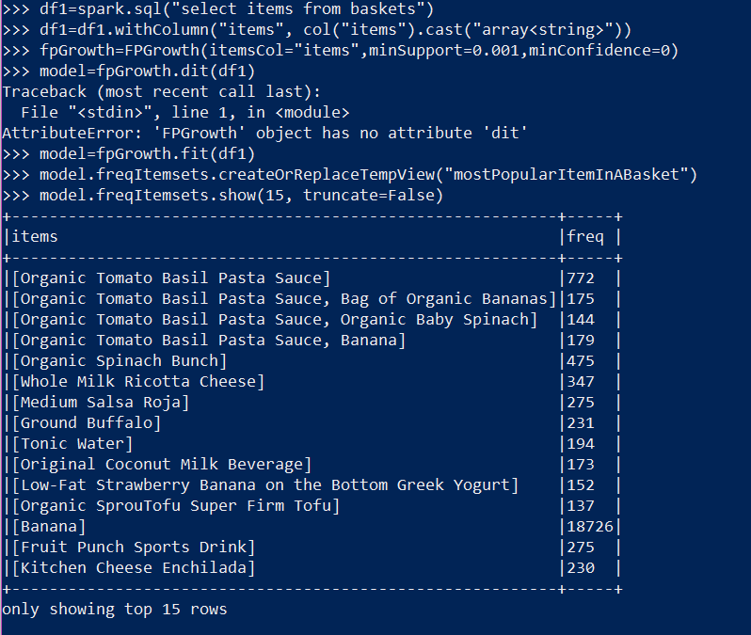

**Assignment 3:**

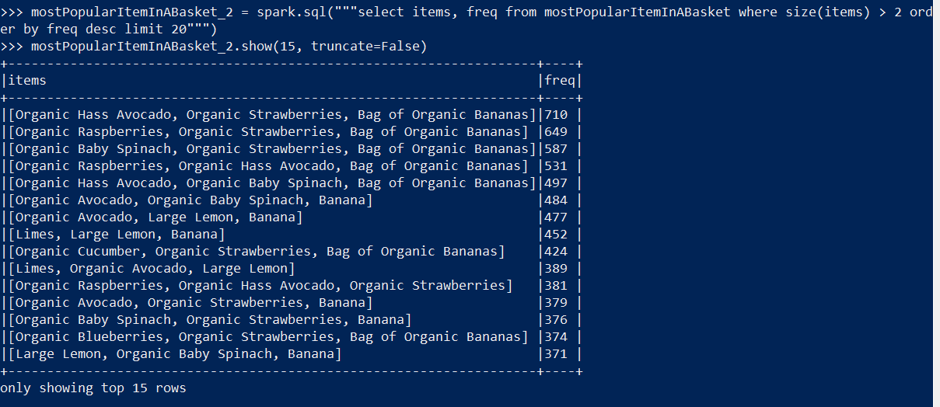

**Assignment 4:**

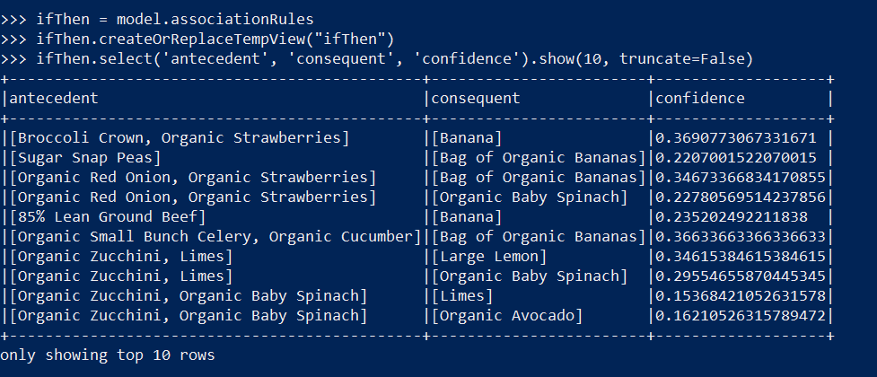

**Assignment 5:**

